AUTOMATED IRRIGATION SYSTEM
❖ Group Members
Names | Roll No | PRN NO
Vinayak desai | 312070 | 22420144
Prathmesh Navale | 312074 | 22420235
Vinod Gaddam | 312075 | 22420255

1. SCE STATEMENT
The Automated Irrigation System is an embedded automation project designed and implemented using Bare-Metal C programming on the STM32F103C8T6 microcontroller (ARM Cortex-M3). The system aims to improve water efficiency in agricultural and domestic irrigation by intelligently monitoring environmental conditions and autonomously controlling the water pump.
The irrigation setup consists of two key sensors: a Soil Moisture Sensor connected to ADC Channel 0 (PA0) and an HL-83 Rain Sensor Module interfaced through a digital interrupt line (PA2). The STM32 continuously reads the soil moisture level using its built-in 12-bit ADC and compares it against a predefined dryness threshold. When the soil becomes dry, the controller activates the water pump via GPIO PA1. Conversely, during rainfall, an EXTI interrupt on PA2 immediately stops the pump to prevent unnecessary water usage.
A push-button input on PA1 ensures controlled startup of the system, while an LED indicator on PA4 provides alert signaling during rain events. configured at the register level without any HAL or library dependencies, demonstrating low-level embedded programming on the ARM CortexM3 architecture.
The overall design combines real-time sensing, interrupt-driven decision-making, and efficient register-level control, resulting in a reliable, low-power, and autonomous irrigation solution that supports sustainable water management.

2. INTERFACING DIAGRAM
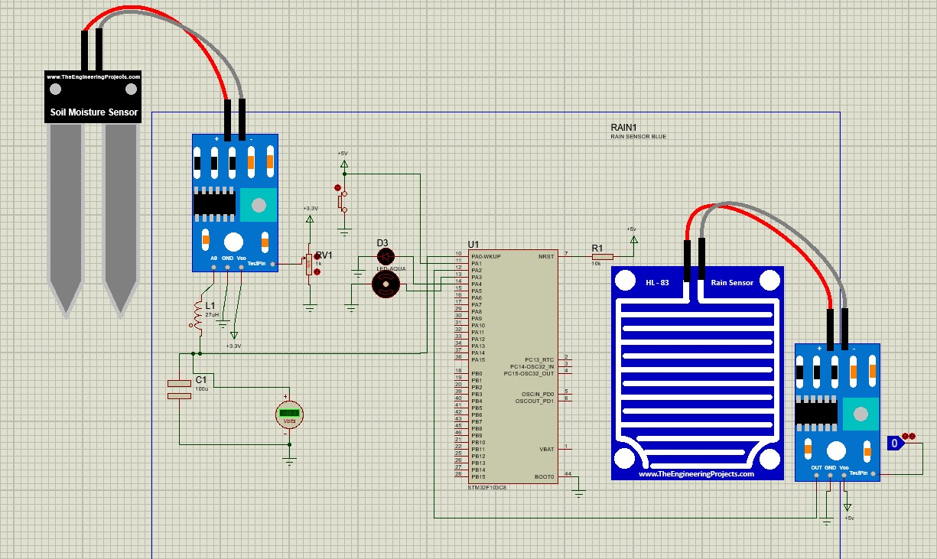
❖ Component Connections
- Soil Moisture Sensor
  - VCC → +5V
  - GND → GND
  - AO → PA0 (ADC Channel 0 – analog input)
- Rain Sensor Module (HL-83)
  - VCC → +5V
  - GND → GND
  - Digital OUT → PA2 (EXTI2 interrupt input)
- Pump Control (Relay / Transistor Driver)
  - Control input → PA3 (digital output)
  - Relay NO + COM → Pump power line
  - Relay coil → Powered by +5V
- Start Button
  - One side → PA1 (input with pull-up)
  - Other side → GND
- LED Indicator
  - LED cathode → GND
  - LED anode → PA4
- Power Supply
  - STM32F103C8T6 → 3.3V
  - Sensors → 5V
  - All grounds → Common GND

3. ALGORITHM
• Algorithm for Main Loop
- Start continuous loop.
- Read external safety switch.
- If the switch is OFF, turn pump OFF and LED OFF, then go back to step 2.
- If rain flag is 0 (rain happening), delay briefly, set rain flag to 1, then go back to step 2.
- Start ADC conversion for soil moisture.
- Read ADC value.
- If ADC value is greater than dry threshold, turn ON pump and turn ON LED.
- Otherwise, turn OFF pump and turn OFF LED.
- Reset ADC reading.
- Go back to step 2.

• Algorithm for External Interrupt (Rain Sensor – EXTI2)
- Detect falling edge on PA2 (rain sensor).
- Generate EXTI2 interrupt.
- Enter EXTI2 interrupt handler.
- Clear the EXTI2 pending flag.
- Set rain flag to 0 (rain detected).
- Turn OFF the pump.
- Blink the LED once.
- Exit the interrupt and return to main program.

❖ Flowchart
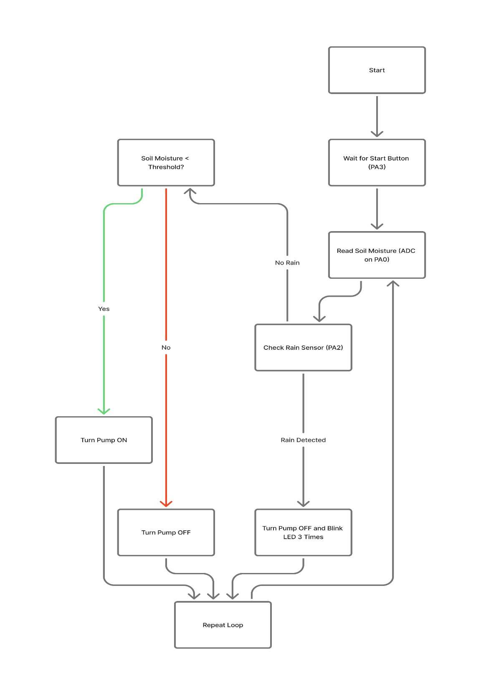

4. BAREMETAL PROGRAM FOR OUR PROJECT

#include <stdint.h>

// RCC (Reset and Clock Control)
#define RCC_APB1ENR (*(volatile uint32_t*)0x4002101C)
#define RCC_APB2ENR (*(volatile uint32_t*)0x40021018)
#define RCC_CFGR (*(volatile uint32_t*)0x40021004)

// GPIOA (General Purpose Input/Output Port A)
#define GPIOA_CRL (*(volatile uint32_t*)0x40010800)
#define GPIOA_IDR (*(volatile uint32_t*)0x40010808)
#define GPIOA_ODR (*(volatile uint32_t*)0x4001080C)

// ADC1 (Analog to Digital Converter)
#define ADC_SR (*(volatile uint32_t*)0x40012400)
#define ADC_CR2 (*(volatile uint32_t*)0x40012408)
#define ADC_SMPR2 (*(volatile uint32_t*)0x40012410)
#define ADC_SQR3 (*(volatile uint32_t*)0x40012434)
#define ADC_DR (*(volatile uint32_t*)0x4001244C)

// EXT_INTERRUPT (External Interrupt/Event Controller)
#define EXTI_IMR (*(volatile uint32_t*)0x40010400)
#define EXTI_RTSR (*(volatile uint32_t*)0x40010408)
#define EXTI_FTSR (*(volatile uint32_t*)0x4001040C)
#define EXTI_PR (*(volatile uint32_t*)0x40010414)
#define NVIC_ISER0 (*(volatile uint32_t*)0xE000E100)

// AFIO (Alternate Function I/O)
#define AFIO_EXTICR1 (*(volatile uint32_t*)0x40010008)

void delay(volatile uint32_t count)
{
while(count > 0)
{
count--;
}
}

volatile uint8_t rain_detected = 0;
volatile uint16_t adc_val;

void EXTI2_IRQHandler(void)
{
// Check if the EXTI line 2 pending bit is set
if (EXTI_PR & (1 << 2))
{
EXTI_PR |= (1 << 2); // Clear the pending flag by writing 1 to the bit
rain_detected = 0; // Set flag to signal rain detected (0 = RAIN, 1 = NO RAIN)

// 1. Turn pump OFF (PA3, bit 3, is driven LOW)
GPIOA_ODR|=(0x1<<3); // Pump OFF

// 2. Blink LED (PA4, bit 4)
GPIOA_ODR |= (1 << 4);
for (int i = 0; i < 300000; i++);
GPIOA_ODR &= ~(1 << 4);
for (int i = 0; i < 300000; i++);
}
}

void ADC1_Init(void)
{
RCC_APB2ENR |= (1 << 9); // ADC1 clock
RCC_APB2ENR |= (1 << 2); // GPIOA

GPIOA_CRL &= ~(0xF << 0); // PA0 analog

ADC_CR2 |= (1 << 0); // ADON ON
for(volatile int i=0;i<1000;i++);

ADC_SMPR2 &= ~(0x7 << 0); // clear
ADC_SMPR2 |= (0x7 << 0); // Sample Time: Max sample time for stability 239.5 ADC clock cycle = 1 / 12,000,000 sec ≈ 83 ns Time = 239.5 × 83 ns ≈ 20 µs

ADC_CR2 |= (1 << 3); // RSTCAL
while (ADC_CR2 & (1 << 3));

ADC_CR2 |= (1 << 2); // CAL
while (ADC_SR & (1 << 2));

// EXTSEL + EXTTRIG for SWSTART
ADC_CR2 |= (7 << 17);
ADC_CR2 |= (1 << 20);
}

uint16_t ADC_Read(uint8_t channel)
{
ADC_SQR3 = channel;

ADC_CR2 |= (1 << 22); // SWSTART

while (!(ADC_SR & (1 << 1)));

return ADC_DR;
}

int main(void)
{
// Enable Clocks: ADC1 | GPIOA |AFIO

// RCC_APB2ENR |= (1<<2);
RCC_APB2ENR |= (1<<0);
ADC1_Init(); // Initiate ADC read

// GPIO Configuration: Clear and Set Modes for Pins PA0-PA4

// PA3 (Pump): Output
GPIOA_CRL&=~(0XF<<12);
GPIOA_CRL|=(0X1<<12);
GPIOA_ODR|=(0x1<<4);

// PA4 (LED): Output
GPIOA_CRL&=~(0XF<<16);
GPIOA_CRL|=(0X1<<16);
GPIOA_ODR|=(0x1<<4);

// PA1 (External Switch): Input Pull-up/Pull-down
GPIOA_CRL&=~(0XF<<4);
GPIOA_CRL|=(0X8<<4);
GPIOA_ODR|=(0x1<<1); // Enable internal Pull-up on PA1

// PA2 (Rain Sensor): Input Pull-up/Pull-down
GPIOA_CRL&=~(0XF<<8);
GPIOA_CRL|=(0x8<<8);
GPIOA_ODR|=(1<<2); // Enable internal Pull-up on PA2

// EXTI Setup (Rain Sensor on PA2)

// Route EXTI Line 2 to PA2
AFIO_EXTICR1 &= ~(0xF << 8);

// Unmask EXTI Line 2 interrupt
EXTI_IMR |= (1 << 2);

// Set EXTI Line 2 to trigger on the Falling Edge
EXTI_FTSR |= (1 << 2);
EXTI_RTSR &= ~(1 << 2); // Ensure Rising Edge is disabled

// Enable EXTI2 interrupt in NVIC
NVIC_ISER0 |= (1 << 8); //allow CPU to accept interrupt there are total 68 external interrupt

// Main Loop
while (1)
{
// Check PA1 (External Safety Switch) status
if ((GPIOA_IDR &(1<<1))==0) // If PA1 is LOW (Switch is ON/Active)
{

// If rain_detected is 0 (set by ISR), rain is detected.
if (rain_detected == 0)
{
delay(10000);
rain_detected = 1; // Clear rain flag
}
else // rain_detected == 1 (NO RAIN)
{

GPIOA_ODR |= (0x1<<4); // Keep LED ON during check
adc_val = ADC_Read(0);
// Check if soil is dry (ADC value > 1400)
if (adc_val>3450)
{
GPIOA_ODR|=(0x1<<4); //LED ON
GPIOA_ODR&=~(0x1<<3); // Pump ON (PA3)

}
else // Soil is wet
{
GPIOA_ODR|=(0x1<<3); // Pump OFF
GPIOA_ODR &=~(0x1<<4); // LED OFF
}

}
}
else
{

GPIOA_ODR|=(0x1<<3); // Pump OFF
GPIOA_ODR &=~(0x1<<4); // LED OFF
}
adc_val=0;

}
}

5. LEARNINGS FORM THE PROJECT
- Understood how STM32 peripherals work using Bare-Metal C and register-level programming.
- Learned configuring GPIO pins as input, output, analog, and pull-up manually.
- Gained experience enabling peripheral clocks using the RCC registers.
- Learned ADC configuration, channel selection, sampling time, and reading sensor data.
- Learned to configure external interrupts (EXTI) and map pins using AFIO registers.
- Gained experience writing and handling interrupt service routines (ISR).
- Understood interfacing of soil moisture sensor (ADC) and rain sensor (digital interrupt).
- Learned how to control a relay/water pump using GPIO output logic.
- Learned combining polling + interrupt-driven control for reliable automation.
- Improved debugging and problem-solving using step-by-step hardware logic analysis.

